One night my mum told me about this old TV show called “ALF” which stands for alien life form. It’s about an alien who crash landed in the garage of an American family. There is a dad called Willie Tanner played by Max Wright, his wife Kate is played by Anne Schedeen, Lynn their daughter is played by Andrea Elson and her little brother Brian who is played by Benji Gregory. Last but not least the main star of the show Alf but his real name is Gordon Shumway.
That night when it all started, Gordon, as I mentioned before, accidentally landed on Tanner’s garage roof. The whole family couldn’t believe their eyes. They carefully took him inside the house and slowly laid him on the coffee table. They were scared at first but when he woke up he started talking and that’s when they realised he could speak English. That’s how Tanner’s family adventure with Alf began.
The series is very old as my mum watched it when she was my age and it was produced in the 80’s. As I got really interested in watching it, my mum surprised me with early birthday present by ordering online the whole set. Ever since I received it, I absolutely love it.
It’s full of laughter and funny stories! Every episode is about Alf coming up with these crazy ideas. He always wants to do good but it always ends badly for him or Tanner’s family members, but in a funny way. However, their bond between each other grows with every episode. Especially Lynn and Brian loves Alf a lot! Kate maybe is not his fan at the beginning but I think she does like him, she is just not showing it much. Alf adores their cat, Lucky, who he would happily eat as it’s something he would do at his old planet, he used to live, called Melmac.
Serious side of every episode is that Tanner’s can’t let anyone see Alf as they are scared that he would be taken away for tests and checks and they would never see him again. Tanner’s have a very nosy neighbour, Mrs Ochmonek and she is the biggest threat to Alf. Yet Alf is always happy to tease her, which makes her think she is going crazy. The way he does it, is so funny.
I think it’s a must see for anyone who likes a good comedy and a laugh. There is not an episode that I wouldn’t laugh my head off watching it. Jokes are easy to understand for young people. Alf is so adorable. I love the way he walks; it is so cute. I wish an alien like him landed in my back garden because I would love to go through all these funny situations they did.
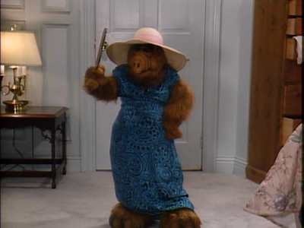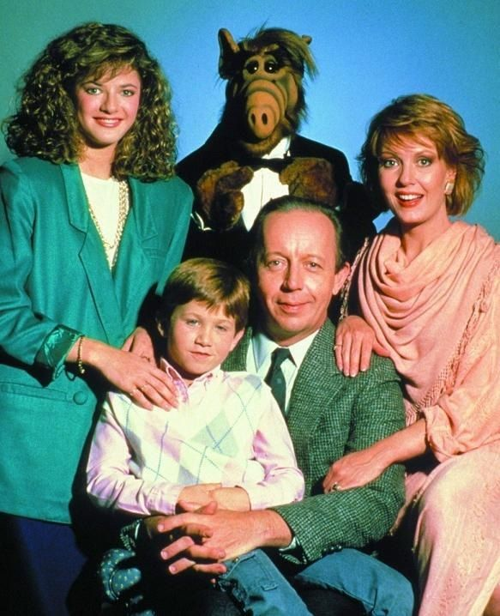
Fantastic review Layla. I love that you have included fronted adverbials, semi colons, relative clause and coordinating conjunctions!
Next time you do some writing can you try to include a simile or metaphor.

