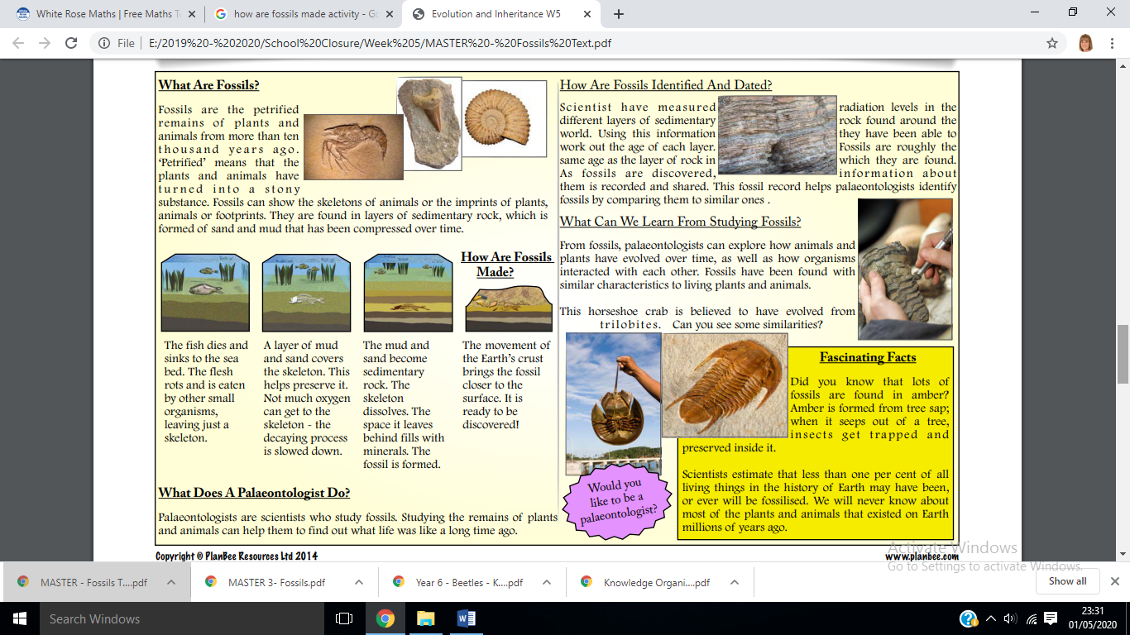**Fascinating Fossil Facts...**