Imploding Can Experiment

By Ryelle Kent
28th April 2020

INTRODUCTION
Today I am experimenting with air compression.

HYPOTHESIS
I think when the can goes into the ice cold water it will crumple up like crispy bacon.

MATERIALS
- An empty aluminum can
- !ce cold water
- Tongs
- Hob

PROCEDURE
- Fill the can with 4 tablespoons of water
- Heat the can until the water starts to boil
- When it is hot enough remove the can with the tongs
- Submerge it in the ice cold water and watch the can implode

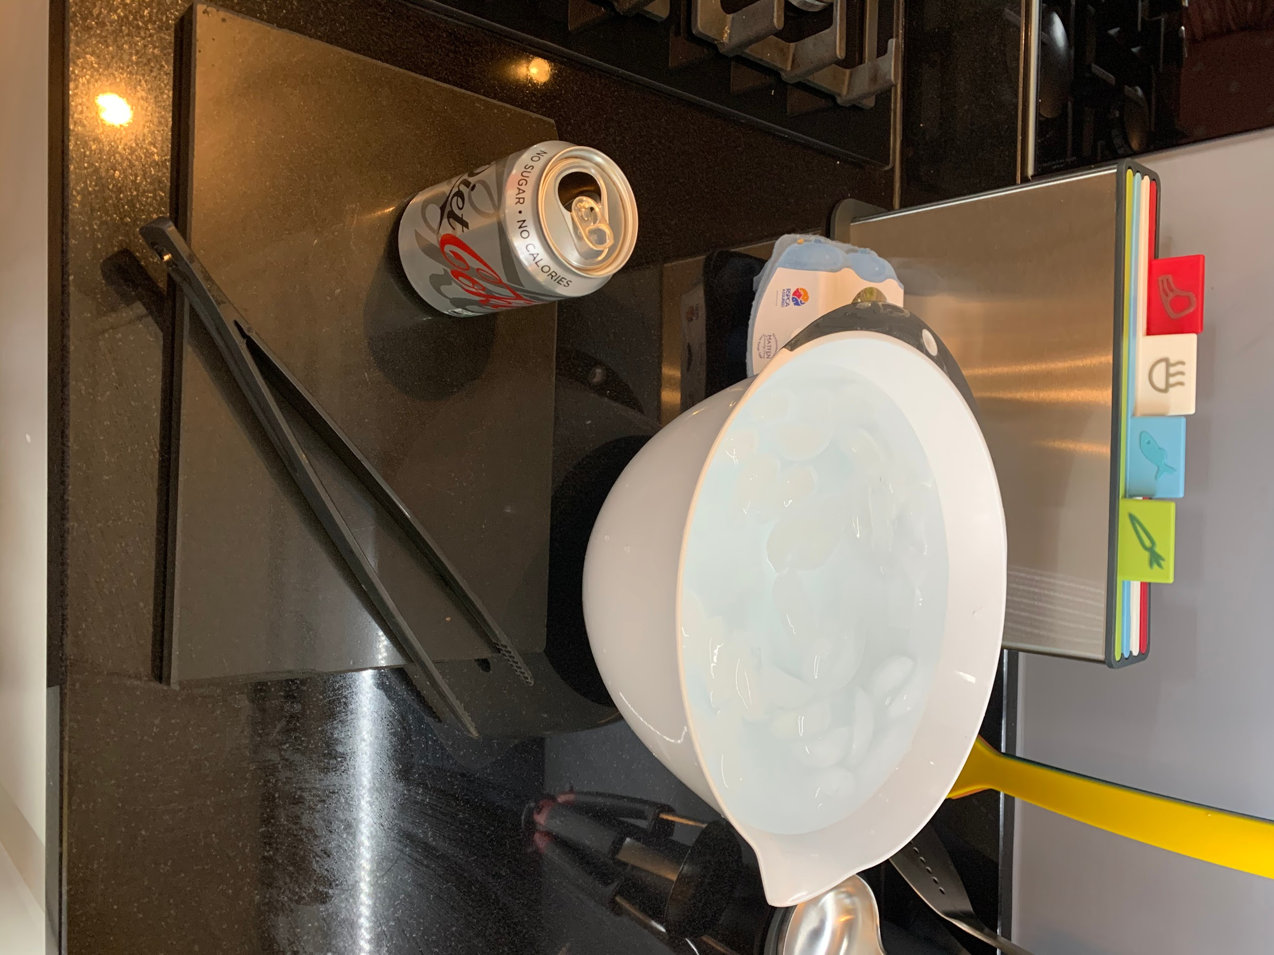

DATA
Attempt | Results | Things to change
1 | FAIL | Increases length of time heating
2 | FAIL | Increase amount of ice cubes
3 | INCONCLUSIVE | Increase amount of water in the can

RESULTS
- The first time we did the experiment, the can did NOT implode. We changed the length of time the can was heated for the second attempt.
- Our second attempt, the can did NOT implode again. For our next attempt we will increase the amount of ice cubes in the bowl.
- Third and final attempt. There were slight dents in the can but not as impressive as I would have liked to see.

CONCLUSION
At the end of this experiment, I thought the last attempt was the best to show imploding can. But it didn’t implode as much as I thought it would so I think the results were inconclusive. The can could have become weaker by the third attempt.

